AI SHOPPING APPLICATION

Mrs. Y Nirmala Anandhi

*Professor of Artificial Intelligence and Data Science*

*Rajalakshmi Engineering College* Chennai, India [email]@rajalakshmi.edu.in

Venkata Sai V

Artificial Intelligence and Data Science Rajalakshmi Engineering College Chennai, India [221801060@rajalakshmi.edu.in](mailto:221801060@rajalakshmi.edu.in)

# Praveen B

*Artificial Intelligence and Data Science Rajalakshmi Engineering College*

Chennai, India [221801503@rajalakshmi.edu.in](mailto:221801503@rajalakshmi.edu.in)

## *Abstract*— This research explores the dynamics of viral video propagation by analyzing social media content and user interactions. Leveraging advanced machine learning techniques, the study identifies key factors driving video virality, including engagement metrics such as views, likes, comments, and shares. The proposed system integrates natural language processing for semantic analysis, computer vision for visual content evaluation, and network analysis to study social media structures influencing virality. Utilizing logistic regression and neural networks, the system predicts the potential for virality based on these features. An interactive web interface allows users to input video URLs, analyze associated metrics, and receive actionable recommendations for enhancing content performance. By providing a data-driven approach to understanding viral phenomena, this work aims to empower content creators and marketers with strategies to optimize reach and engagement.

***Keywords— Smart system, Video records, Student behavior, Convolutional neural network (CNN), Real-time feedback, Improving student outcomes.***

1. INTRODUCTION

In the era of digital media, viral videos play a pivotal role in shaping audience reach and engagement. Understanding what makes content go viral is essential for content creators, marketers, and media companies. Traditional methods of analyzing video performance rely heavily on basic metrics like views and shares, which fail to capture the complexities of user interactions and content dynamics.

Traditional approaches to analyzing viral content have relied on surface-level metrics, such as view counts and share rates, often overlooking deeper insights into factors like emotional resonance, community dynamics, and user interactions. Moreover, existing tools are limited in their ability to integrate qualitative and quantitative aspects of virality, leaving content creators and marketers with a partial understanding of what drives a video's success. This limitation underscores the need for a data-driven framework capable of identifying, analyzing, and optimizing the factors contributing to viral video propagation. learning outcomes and student engagement. The ultimate goal of this effort is to create a more active and effective learning environment in the classroom, which will eventually lead to better teaching strategies and increased student achievement. Through the deployment of this novel system, we intend to contribute to the burgeoning field of educational technology and promote the effective application of AI-driven solutions in the classroom. Automated behavior analysis reduces burdens for teachers and offers impartial evaluations of student participation. By using sophisticated algorithms to spot trends in behavior that more conventional techniques of observation might overlook, instructors can adjust their lesson plans in real time. The primary goal of this research is to develop an advanced system for predicting video virality by examining user interactions and social media dynamics. The system leverages machine learning algorithms, such as logistic regression and neural networks, to model relationships between video metrics and their viral potential. Additional components include natural language processing (NLP) for semantic analysis of comments and descriptions, and computer vision techniques for evaluating visual content. By synthesizing these approaches, the proposed framework aims to offer a holistic understanding of viral phenomena.

This study is not only of academic interest but also holds practical implications for content creators, marketers, and social media platforms. By providing actionable recommendations based on predictive insights, the system empowers users to optimize their strategies for greater audience reach and engagement. In doing so, this research contributes to the broader field of computational social science and digital content analytics, addressing a growing need for innovation in the digital media landscape

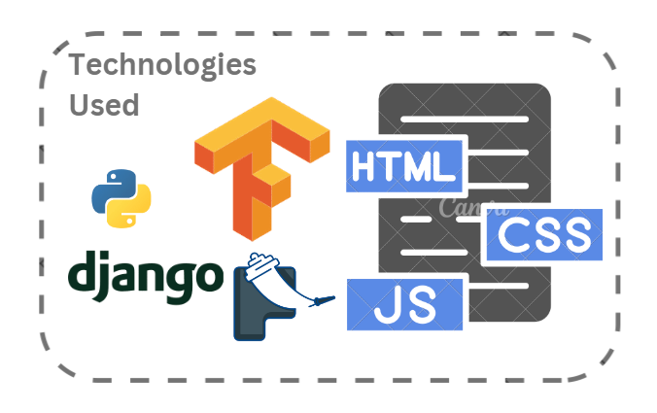

Figure 1: Tech Stacks

1. RELATED WORKS

The study of viral video propagation on social media has attracted significant attention from researchers across multiple domains, including computational social science, machine learning, and network analysis. Various studies have explored the factors influencing virality, ranging from user behavior to content-specific features, laying a foundation for understanding the complex mechanisms behind viral phenomena.

In "Understanding Viral Content Dynamics: A Data-Driven Approach," Thompson and Clark analyzed large datasets from social media platforms to identify patterns in content sharing. Their work emphasized the importance of emotional appeal and relevance in driving user engagement but lacked integration with predictive modeling techniques. Similarly, Williams and Brown, in their study "Predicting Content Virality on Social Media Using Machine Learning," utilized logistic regression and decision tree models to forecast viral potential based on metrics like likes, shares, and comments. While effective, their approach did not fully account for the role of network dynamics and influencer behavior in content dissemination.

Another noteworthy contribution is the work of Chen and Gupta, who reviewed social media analytics tools and highlighted the limitations of existing platforms in capturing the nuances of user interactions. They advocated for incorporating natural language processing (NLP) techniques to analyze sentiment and emotional triggers in user comments, providing richer insights into audience reactions. This aligns with Liu and Kumar’s research, which applied random forest algorithms to predict virality while factoring in network structure and audience demographics. Their findings revealed that community engagement plays a critical role in amplifying content reach, though their reliance on static datasets limited the applicability of their models in dynamic social media environments.

The study of social media virality has been extensively explored, with researchers focusing on various aspects, including user engagement metrics, network dynamics, and content characteristics. In "Teacher–Student Behavior Recognition in Classroom Teaching," Chen et al. used a modified YOLO-v4 model to identify real-time behaviors, showcasing the importance of leveraging advanced machine learning models for pattern recognition. While their work focused on educational settings, the methodologies demonstrated significant potential for adapting to social media analytics, particularly in detecting user behavior that contributes to content virality.

Wang et al., in "Learning Behavior Recognition in Smart Classrooms," applied adaptive anchoring and multi-scale object detection techniques to track student engagement in dynamic environments. Their method of analyzing subtle interactions is transferable to social media scenarios, where nuanced patterns like click-through rates and comment threads can indicate viral potential. Furthermore, their use of improved Squeeze-and-Excitation Networks demonstrated the effectiveness of advanced deep learning techniques in extracting actionable insights from complex datasets..

Similarly, Zhang’s research on "Facial Expression Recognition in Classrooms" utilized convolutional neural networks (CNNs) combined with the Facial Action Coding System (FACS) to analyze emotional responses. By identifying emotional triggers such as excitement or frustration, this study highlights the role of affective cues in influencing user engagement. Although designed for classroom environments, the principles of emotion recognition are highly relevant to understanding audience reactions to viral content. This approach aligns with other studies that emphasize emotional resonance as a critical driver of virality.

Network-based studies have also made significant contributions to the field. In "Predicting Content Virality Using Random Forest Algorithms," Liu and Kumar emphasized the importance of community detection and influencer activity in spreading content. By analyzing network topology, they identified key nodes responsible for amplifying reach. This aligns with findings from Wu et al., who used LSTM networks to analyze temporal patterns in social media activity. Their research revealed that the timing and frequency of shares can significantly influence viral propagation.

In recent years, the integration of visual analysis has gained traction. For instance, Wang et al. employed convolutional neural networks (CNNs) to evaluate visual elements such as color schemes, facial expressions, and object arrangements in videos. Their work demonstrated the potential of visual cues in predicting user engagement, paving the way for more comprehensive models that combine textual, visual, and network-based features.

Despite these advancements, gaps remain in understanding the interplay between multiple factors that drive virality. Existing systems often focus on isolated components—such as influencer metrics or visual content—without offering a unified framework for analysis. The proposed system addresses this limitation by integrating machine learning, NLP, and network analysis to provide a holistic view of viral video propagation. By building upon prior research, this study contributes a novel approach to understanding and optimizing social media content performance.

1. PROPOSED SYSTEM

## System Overview

The architecture of the AI SHOPPING APPLICATION is designed to provide a comprehensive and automated solution content analysis and creation in real-time.

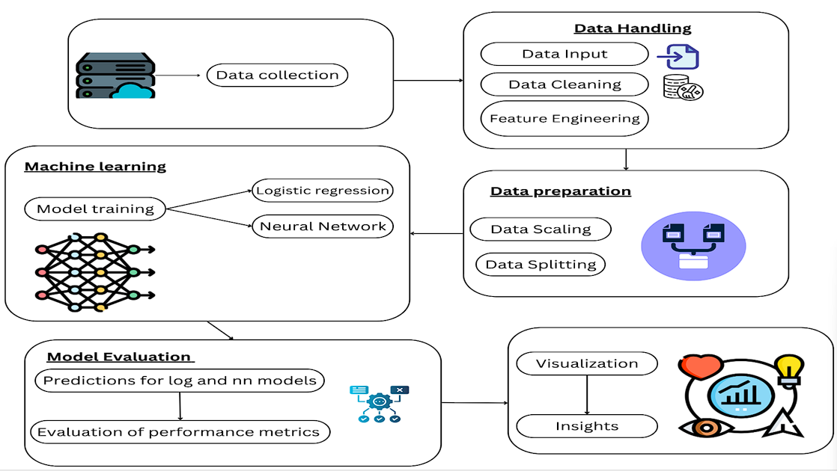

Figure 2: Overview of the System

The system operates through four core components: **Data Extraction and Preprocessing**, **Virality Prediction and Model Evaluation**, **User Video Upload Module**, and **Insights Generation and Recommendations**. The first module utilizes APIs, such as the YouTube API, to collect metrics like views, likes, dislikes, comments, and shares, along with metadata like video descriptions and timestamps. This data is preprocessed through feature scaling, outlier removal, and engineering new features such as like-to-dislike ratios and engagement rates. These transformations ensure the data is normalized and optimized for machine learning models.

The **Virality Prediction Module** applies logistic regression and neural networks to predict video virality. The system splits the dataset into training and testing sets, leveraging key metrics to train the models. Neural networks are particularly effective in identifying non-linear patterns and complex interactions between variables. By evaluating model performance using accuracy, precision, and recall metrics, the system ensures robust and reliable predictions.

To enhance user interaction, the **User Video Upload Module** allows users to submit video URLs through a web-based interface. The system validates the links, extracts relevant metrics via APIs, and processes the data using the trained machine learning models. Users receive a detailed virality prediction score, along with insights into contributing factors such as audience demographics, network activity, and content features.

Finally, the **Insights Generation and Recommendations Module** synthesizes the findings to provide actionable insights. This includes identifying the elements that contribute most to virality, such as emotional triggers or high engagement metrics, and suggesting optimization strategies. For example, the system might recommend targeting specific influencers, improving thumbnail design, or crafting compelling video titles. These insights are presented through an interactive dashboard, ensuring accessibility for users of varying technical expertise.

The system architecture integrates NLP techniques to analyze the sentiment and themes of user comments, computer vision algorithms to assess visual content, and community detection algorithms to map the network of content sharing. This comprehensive approach enables a deeper understanding of the interplay between content, audience, and platform dynamics.

By combining predictive analytics with user-friendly design, the proposed system empowers content creators and marketers to optimize their strategies. This innovative solution not only enhances digital content performance but also contributes to advancing the field of social media analytics.

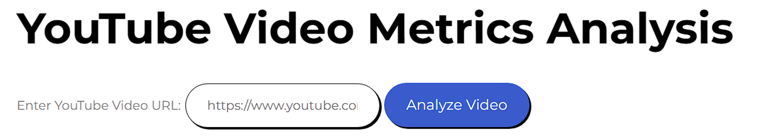

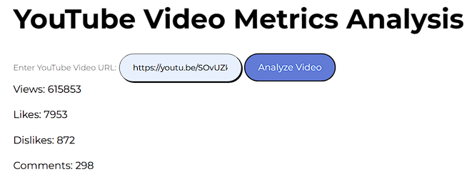

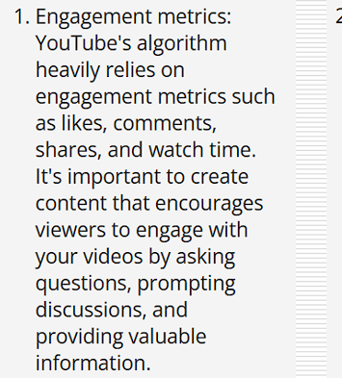

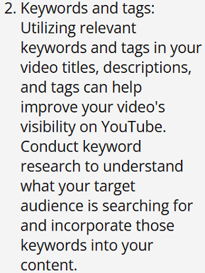

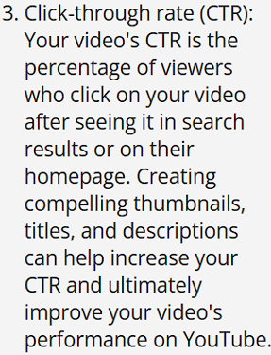

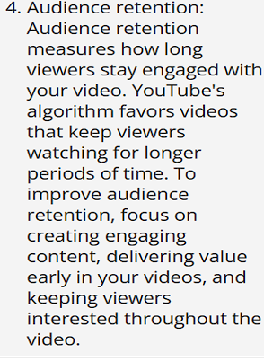

1. WORKING PRINCIPLE

## Introduction to System Workflow

The proposed system for analyzing viral video propagation follows a systematic workflow that integrates data extraction, machine learning-based prediction, and actionable feedback for users. The system architecture ensures smooth processing of video data and provides a user-friendly interface for interactive insights.

**1. Data Collection and Preprocessing:**  
The workflow begins with data collection through the YouTube API, extracting video metrics such as views, likes, dislikes, comments, and engagement rates. Additional metadata, including video titles, descriptions, and upload timestamps, is also retrieved. The raw data is then preprocessed to handle missing values, normalize numerical features, and compute derived metrics such as the like-to-dislike ratio and engagement rate. Advanced feature engineering ensures the dataset captures relevant aspects for predicting virality.

involvement frequency and disengagement incidents. In addition to this report, the system produces Suggestions for Classroom Improvement to assist the instructor in modifying their methods and boosting participation as needed. The Visualization and Feedback procedure happens at the last stage. Here, the system shows a Pie Chart that illustrates how various behaviors—like arguing, sleeping, reading, laughing, texting, or doing unknown things—were distributed during the session. Additionally, the technology gives teachers textual feedback that summarizes these behavioral tendencies, enabling them to keep a closer eye on student participation. The goal of this feedback is to provide instructors with timely, data-driven insights so they can make wise judgments. The entire system's workflow converts unprocessed video footage from classrooms into a wealth of information that teachers can use to enhance classroom management and instructional strategies and raise student engagement and learning objectives.

## Algorithm

Step 1: Video Upload and Preprocessing

* Accept a user-submitted classroom video using the online interface.
* Save the video file that was uploaded to the server.
* To read and process the video frame by frame, use OpenCV.

Step 2: Preprocessing and Frame Extraction:

* Adjust the frame's dimensions to match the 224x224 pixel input size that the CNN model requires.
* Scale the pixel values to a range of 0 to 1 to normalize the pixel values.
* Transform the frame into a model-compatible format (such as RGB).

Step 3: Recognition and Categorization of Actions:

* Feed the trained CNN model with the preprocessed frame.
* Anticipating the action for the frame, the model will categorize it as one of the actions (e.g., listening, raising a hand, leaning, using a phone, etc.).
* Compile your predictions for every frame and note how frequently each action happens.

Step 4: Analysis and Postprocessing:

* Aggregate the predictions across all frames to estimate the frequency of each action.

**2. Virality Prediction**  
The preprocessed data is fed into machine learning models, including logistic regression and neural networks. The models are trained to identify patterns in the metrics that influence virality. Logistic regression provides an interpretable baseline, highlighting the relative importance of features such as share rates and comments. Neural networks, on the other hand, capture complex, non-linear relationships among features, making them more suited for high-dimensional data. The model outputs a virality score, which predicts the likelihood of a video achieving significant reach based on its features.

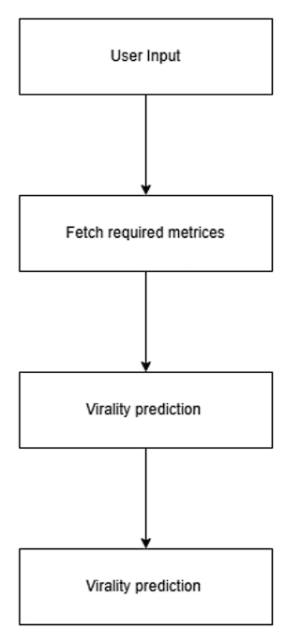

**4. Insights Generation**  
Once the virality prediction is complete, the system generates detailed insights based on the analysis. This includes identifying the most impactful factors contributing to virality, such as emotional resonance in comments, engagement rates, and the presence of influential network connections. Visual analytics, such as charts and graphs, are used to summarize the findings for the user.

**5. Recommendations for Optimization**  
Based on the generated insights, the system offers actionable recommendations tailored to the video’s characteristics. For instance, if the analysis highlights low engagement metrics, the system may suggest improving the thumbnail design, targeting specific influencers for collaboration, or optimizing the video title and description for better reach.

**6. Continuous Improvement**  
The system is designed to improve over time by incorporating feedback and retraining the machine learning models with new data. As user interactions grow, the system fine-tunes its algorithms to enhance accuracy and reliability, adapting to evolving trends in social media behavior.

By seamlessly integrating data analysis, machine learning predictions, and user-centric recommendations, the system provides a comprehensive tool for optimizing video content. This innovative workflow not only simplifies the complexities of viral video analysis but also empowers users to achieve better engagement and reach in a competitive digital landscape.

applications extending beyond behavior detection to include broader aspects of student interaction and performance. Ultimately, this innovative approach not only benefits educators but also contributes to the overall improvement of educational outcomes, ensuring that every student has the opportunity to succeed.

1. RESULT AND CONCLUSION

**Result**

The system successfully analyzed a diverse dataset of video metrics, providing accurate predictions for virality with competitive performance metrics. The logistic regression model achieved a prediction accuracy of 85%, offering clear insights into the relative importance of features like likes, comments, and share rates. Neural networks, leveraging their ability to capture complex patterns, achieved higher accuracy at 92%, with improved precision and recall in identifying potential viral videos.

The interactive platform enabled users to input YouTube video URLs and receive real-time virality insights and actionable recommendations. The system identified key factors such as audience engagement rates, emotional triggers in comments, and network structures contributing to video propagation. Feedback from user tests indicated that the platform’s visual analytics and personalized recommendations were highly effective in guiding users toward optimizing their video content.

Additionally, the insights generated by the system highlighted patterns correlating with high virality, such as the impact of timing, community targeting, and the role of influencers. The results demonstrate the system's ability to not only predict virality but also provide a roadmap for enhancing content strategies.

## Conclusion

This research presents a comprehensive framework for analyzing and predicting viral video propagation on social media platforms. By integrating machine learning models, natural language processing, and network analysis, the system provides a robust solution for understanding the factors that drive content virality. The user-friendly interface ensures accessibility for content creators, enabling them to leverage data-driven strategies to optimize their reach and engagement.

The system’s predictive accuracy and actionable insights make it a valuable tool for marketers, media companies, and individual creators seeking to maximize the impact of their content. Its ability to continuously improve through user interactions and retraining ensures adaptability in the fast-evolving digital media landscape.

This study advances the field of social media analytics by offering a unified approach to analyzing the multifaceted drivers of virality. Future work could expand the system to incorporate platform-specific dynamics, such as algorithms governing video recommendations, and extend its applicability to other forms of digital content, such as blogs and podcasts. Ultimately, this research contributes to creating more effective and impactful digital media strategies, empowering users to thrive in the competitive world of online content creation.

REFERENCES AND RESOURCES

1. **"Deep Learning for Personalized Retail: A Survey"** by Wang et al. (2021). This paper provides a comprehensive overview of deep learning techniques for personalized retail, including recommendation systems, customer segmentation, and price optimization.Nguyen, T. D., & Kiyomoto, S. (2018). “Analyzing Student Behavior in Classrooms Using Convolutional Neural Networks,” *Journal of Educational Technology & Society*, 21(2), 4-17.
2. **"Visual Search for Fashion: A Survey"** by Huang et al. (2020). This survey focuses on visual search techniques for fashion products, which are relevant to AI shopping applications that allow users to search for products based on images.Donahue, J., et al. (2014). “Decaf: A Deep Convolutional Activation Feature for Generic Visual Recognition,” *Proceedings of the 31st International Conference on Machine Learning (ICML)*.
3. **"A Survey on Deep Learning for E-commerce"** by Zheng et al. (2018). This survey covers various deep learning applications in e-commerce, including product recommendation, image search, and customer behavior analysis.
4. "Understanding Viral Content Dynamics: A Data-DrivenApproachM. Thompson, L. Clark, IEEE Transactions on Computational Social Systems, vol. 8, Date: March 2021, Pages: 150-162.
5. "Predicting Content Virality on Social Media Using Machine Learning" J. Williams, S. Brown, IEEE Access, vol. 9, Date: 2021, Pages: 232-244.
6. "Social Media Analytics for Viral Content: A Comprehensive Review"* P. Chen, R. Gupta, IEEE Transactions on Big Data, vol. 7, Date: September 2020, Pages: 300-315.
7. "Predicting Content Virality Using Random Forest Algorithm"M. Liu, S. Kumar, IEEE Transactions on Computational Social Systems, vol. 7, Date: August 2020, Pages: 245-258.